Project Report

# GitHub URL

https://github.com/garmc/UCDPA_Gary-McInerney.git

# Abstract

(Short overview of the entire project and features)

This project aims to illustrate the Republic of Ireland’s wind energy resources. It will contain information about current connected wind farm locations to illustrate the areas where wind farms are concentrated and how long they have been in operation. It will also aim to show the planned wind farm projects in each county/province of the country.

The project features the following:

-An imported csv file.

-Wind farm data which I’ve scraped from the web.

-Preparation of the data using a Pandas dataframe.

-Data analysis using conditional statements, looping, groupby, NumPy functions and dictionaries/lists.

-Data visualisation with the aid of charts from Matplotlib and Seaborn.

-The use of machine learning to make predictions. Classification or regressive methods?

# Introduction

(Explain why you chose this project use case)

First and foremost, I chose this project use case as I have a keen interest in renewable energy. Wind energy has the potential to provide vast quantities of electricity to the national grid and really transform how we live. According to Wind Energy Ireland’s most recent report, wind energy has supplied 33 per cent of Ireland’s electricity demand so far this year. The month of October saw a record volume of electricity produced by Irish wind farms and the share of demand met by the country’s primary renewable energy source (Wind Energy Ireland, 2022).

I’m an employee of the ESB and therefore have an insight into the drive towards a cleaner energy future from an industry perspective. The ESB, in line with the Irish Government's target that 80% of all power used in the Republic of Ireland be generated from renewables by 2030, is committed to expanding its own collection of low-carbon generation assets including wind farms. For example, in 2019 the partnership of ESB and Bord na Mona finished the first phase of Oweninny Wind Farm in Co Mayo which added 89 KW of capacity to Ireland’s wind assets with a further 83KW to come when phase two is completed. (ESB, 2022)

The current spike in energy prices caused by inflation and the war in Ukraine has highlighted the huge reliance that countries like Ireland have on imported fossil fuels to enable our economies to function. In fact, fossil fuels provide 85% of Ireland’s energy needs. According to research done by UCC, a move away from fossil fuels is likely to take two to three decades to achieve. Despite the relative success that Ireland has enjoyed in producing clean energy through renewables, it's contribution to overall energy use is small (Deane, 2022). Therefore, one can say, that there is much growth potential for renewables such as wind and I would like to examine this in in my report.

# Dataset

(Provide a description of your dataset and source. Also justify why you chose this source)

The dataset that I’ve chosen is a list of the connected wind farms in the Republic of Ireland as of June 2022. The data is presented in tabular format and contains information about the wind farm name, location, the present status of the wind farm in the development process, installed capacity in megawatts and the year of connection.

The dataset comes from the data.gov.ie website and has been derived from the Sustainable Energy of Ireland (SEAI)’s Wind Farm Atlas. The Wind Atlas is a digital map of wind energy resources in Ireland. It contains detailed information on wind speeds and directions at different heights above ground level, and current windfarms. This data is used when determining the appropriateness of wind resources in certain areas. The objective is to help policy makers, local governments and community organisations in the early stages of planning. Additionally, it aims to educate developers and the wider population on Ireland’s current wind resource situation in the most data driven and constructive way possible (SEAI Wind Atlas, 2022).

I’ve chosen this source as the SEAI is the leading state authority on all aspects of renewable energy and provides data in a readily available and accessible way. Their extensive collection of data includes details on research projects and funding, broad-based national and sectoral energy figures, and behavioural insights to influence the societal switch to more sustainable practices (SEAI Data and Insights, 2022).

# Implementation Process

(Describe your entire process in detail)

**Importing:**

Imported the csv file (<https://seaiopendata.blob.core.windows.net/wind/WindFarmsConnectedJune2022.csv)> to a Jupyter Notebook.

Retrieved the url 'WindFarmsConnectedJune2022.csv' from the csv file.

I used web scraping from the website 'https://windenergyireland.com/about-wind/the-basics/facts-stats' in order to back up the windfarms dataset. The html data from this website is referred to as ‘windenergy’.

With the aid of the Beautiful Soup package, I converted the html data into a more readable form and named it ‘windcapacity’.

Using the FindAll function, I identified the total wind capacity in MW for the Republic of Ireland from ‘windcapacity’ and named it windroi. The .text.strip() function was used to produce the 4,3225 MW figure in the notebook.

**Preparation and Analysis:**

I created a Pandas DataFrame from the csv file and named it ‘wfarms’. Setting the parameter index_col=0 means that the first column i.e. ‘Windfarm_Name’ appears as the index. I found the total of all the missing values in the dataframe via the isnull().sum() function and used fillna () function to replace them with zeros.

The for loops iterrows function is used to show information about each dataframe row by the windfarm name label.

For the purposes of this project, I decided to concentrate on four of the columns in the dataframe- ‘County’, ‘Present_Status’, ‘MEC_MW’ and Year_ of_ Connection. Therefore, I removed all the other columns that weren’t deemed necessary and named the modified dataframe ‘wfmod’.

As the column ‘MEC_MW’ is a bit unclear, I renamed it ‘Max Capacity MW’ to better illustrate the information. I filtered the dataframe by ‘Year of Connection’ and ‘Max Capacity MW’ and later used this information to produce the first chart in the visulation section of the project. The first Irish windfarm was commissioned at Bellacorrick, Mayo in 1992 (Wind Energy Ireland, 2022), so I decided to filter the dataframe from that year up to including 2007 (the mid point of the last thirty years) to show the number of windfarms that have been energised or connected in that period. Additionally, in order to convey the growth in wind farm activity since then, I filtered the dataset to show all windfarms that have been energised or connected after 2007. I sorted the dataframe by the column ‘Max Capacity MW’ in descending order to identify the windfarms with the most energy capacity in the Republic of Ireland. I also put a filter on the ‘County’ column to produce the number of offshore windfarms.

Used the .groupby() method to group the data by the column ‘Year_of_Connection’ to convey the average maximum capacity of the windfarms built each year since 1997 to present.

I imported an excel file from the ourworldindata website which shows the installed wind energy capacity of Ireland and five other small European countries (Austria, Belgium, Denmark, the Netherlands and Portugal) AND indexed the dataframe by country name.

I renamed the column ‘Wind Capacity’ as ‘Wind Capacity_GW’ to show that this dataframe has a wind measurement of gigawatts compared to the megawatts used in the first dataframe of Irish wind farms.

I dropped the column ‘Code’ and rounded each of the values in the wind capacity column to two decimal places.

I created a list of the wind energy values for each country and converted them into Numpy arrays to establish the mean wind capacity between 1997 and 2021. Furthermore, I defined a custom function to get the increase in wind energy capacity from the first value in 1997 to the last value in 2021.

**Visualisation:**

Imported Matplotlib to generate the first chart and used the filtered data relating to the year of connection and energy capacity. As there were over three hundred wind farm projects either energised or connected over that period, I manually calculated the sum total of energy capacity in each year and put the values into a list alongside the list of years. I used the plt. functions to plot the ‘year’ on the x-axis, ‘capacity mw’ on the y-axis and put a title ‘Wind Energy in Ireland’ on the chart.

I decided to use Seaborn to produce the second chart based on the excel file imported from the Our World in Data website (Statistical Review of World Energy-BP, 2022) and named the dataset ‘countries_cap’. I renamed the ‘Wind Capacity’ as ‘Wind Capacity GW’ and used the sns.scatterplot() function to create the chart axes, the title and the colour scheme for the countries.

# Results

(Include the charts and describe them)

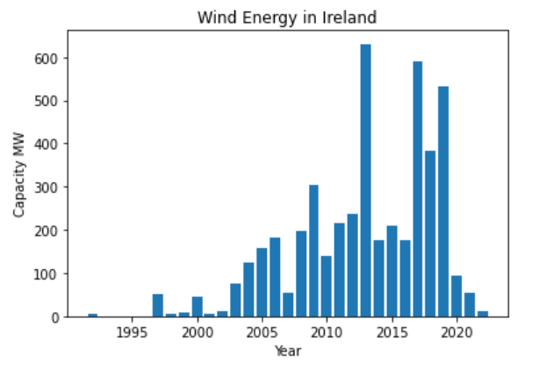

The first chart is a Matplotlib bar chart which shows the wind energy activity in Ireland over the past thirty years. On the x-axis is the year and on the y-axis is the energy capacity in megawatts. The x-axis has intervals of five years and the y-axis has intervals of 100 which is well spaced out and fitted very well with the time period. The bars clearly indicate the differing levels of wind farm generation during this period. Overall, there is a fluctuating trend in the chart with most years

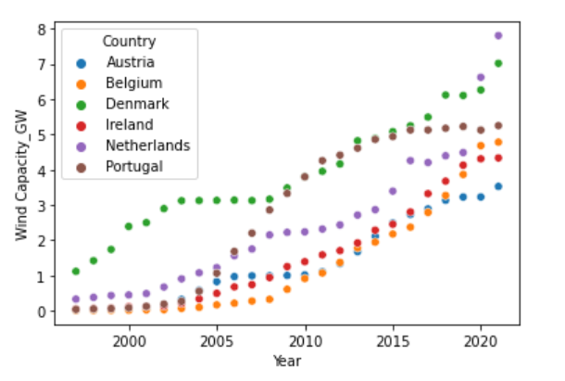

The second chart is a Seaborn scatter plot chart which shows Ireland’s wind energy generating capacity figure in gigawatts versus five other small European countries for each year between 1997 and 2021. On the x-axis is the year, on the y-axis is the wind capacity in gigawatts and the hue based is on the six countries in the dataset. The different colours representing the countries are distinct and gives the data an attractive look. Overall, the scatterplot makes it easy to identify the general trend.

# Insights

(Point out at least 5 insights in bullet points)

* There has been a huge increase in the number of wind farms energised or connected in Ireland after 2007. In fact, 76% of the country’s total wind energy capacity has been contributed in the past 15 years. This has coincided with increased investment and a general reduction in the cost of renewable energy.
* The western and mid-western parts of Ireland are where the majority of the wind farms are located- Donegal (45), Kerry (36), Tipperary (29), Limerick (18) and Mayo(15), Clare (13), Leitrim(13), Galway(11) and Sligo (7). It’s no surprise given the proximity of these counties to the strong winds coming off the Atlantic Ocean.
* The highest average maximum capacity from wind projects was 54.3 MW in 2021 and the lowest average maximum capacity was 2.65 MW in 1999. There were some outstanding years for total capacity from wind farms in 2013 (630.71 MW) , 2017(590.36 MW), 2018 (383.91 MW) and 2019 (531.11 MW) before a sharp drop in 2020 and 2021 owing to the Covid pandemic.
* With only one offshore wind farm in Arklow Bank, Wicklow, there is huge potential for the development of Ireland’s offshore wind resources. As an island nation with lots of wind, we could use our natural advantage to become a world leader in offshore wind energy generation.
* The Netherlands (7.8 GW) and Denmark (7.01 GW) are clearly well ahead of other similar sized European countries in terms of wind generation capacity. This could be as a result of their progressive energy policies compared to the more conservative political style found in countries like Ireland.

**Machine Learning:**

Describe what kind of prediction you could perform in future using machine learning and/or deep learning.

Machine learning can be used to predict the wind generating capacity in a certain country into the future.

I would use regression methods as this is used to predict numerical values

# References

The Sustainable Energy Authority of Ireland (2022) *Wind Farms in Ireland-Wind Farm Locations in CSV*. Available at: <https://data.gov.ie/dataset/wind-farms-in-ireland/resource/9a93472a-28e8-4e1b-bb53-49e89d7b6eb9> (Accessed 26 October 2022).

Wind Energy Ireland (2022) *Wind Energy Monthly Report-nearly half of Ireland’s power provided last month*. Available at: <https://windenergyireland.com/latest-news/7138-wind-energy-monthly-report-nearly-half-of-ireland-s-power-provided-last-month> (Accessed 4 November 2022).

ESB (2022) *ESB and Renewable Energy.* Available at: <https://esb.ie/what-we-do/generation-and-trading/esb-and-renewable-energy> (Accessed 4 November 2022).

Deane, P. (2022) *The Russian Energy Crisis and Ireland’s reliance on fossil fuels.* Available at:<https://www.rte.ie/brainstorm/2022/0302/1283868-ireland-fossil-fuels-russian-energy-crisis/> (Accessed 4 November 2022).

The Sustainable Energy Authority of Ireland (2022) *Wind Atlas.* Available at: <https://www.seai.ie/technologies/seai-maps/wind-atlas-map/> (Accessed 28 October 2022).

The Sustainable Energy Authority of Ireland (2022) *Data and Insights.* Available at: <https://www.seai.ie/data-and-insights/> (Accessed 26 October 2022).

Wind Energy Ireland (2022) *Wind Stats.* Available at:<https://windenergyireland.com/about-wind/the-basics/facts-stats> (Accessed 30 October 2022).

Statistical Review of World Energy - BP (2022) *Installed Wind Energy Capacity.* Available at:<https://ourworldindata.org/grapher/cumulative-installed-wind-energy-capacity-gigawatts?country=IRL~PRT~DNK~BEL~NLD~AUT> (Accessed 20 November 2022).

John, D.K.(2022) *How to Round Numbers in Pandas Dataframe.* Available at: <https://datascientyst.com/round-numbers-pandas-dataframe/#:~:text=Setup%201%20Step%201%3A%20Round%20up%20values%20to,Step%206%3A%20Round%20values%20in%20the%20whole%20DataFrame> (Accessed 20 November 2022).

Propero Coder (2020) *How to Calculate a Percentage Change Using Python.* Available at: <https://prosperocoder.com/posts/python/calculate-percent-change/> Accessed 19 November 2022).